# **Name: Abdurrahman Qureshi**

# **Roll No: 242466**

Practical No: 10

Date Of Performance: 10/09/2025

Aim: To understand Docker Hub's purpose, install Docker on an AWS EC2 Ubuntu instance, work with container images, and learn essential Docker commands for container management.

1. What is hub.docker.com?
2. What is docker hub used for?
3. Install docker on AWS EC2 –Ubuntu by using curl

#curl -fsSLhttps://get.docker.com -o get-docker.sh

#sh get-docker.sh

1. Run hello-world from docker hub and explain the steps
2. Pull 3 or 4 images ,one of the python , run “ Hello World “ inside container.
3. Demonstrate any 15 docker command and explain its uses   
   [Terminate the resources after performing the practical- terminate environment and application both]

****ANS.1:****

**hub.docker.com, commonly known as Docker Hub, is the world's largest public repository and community for container images. Think of it as:**

* **GitHub for Docker Images: Just as GitHub hosts code, Docker Hub hosts pre-built, ready-to-run application packages called container images.**
* **A Public Library: It's a central, cloud-based registry where developers and companies can store, share, and distribute their container images.**
* **A Source of Official Software: Major software vendors like Ubuntu, Python, Node.js, Nginx, Redis, and MySQL publish their official, verified images on Docker Hub. This ensures you get a trusted, standard version of the software.**

****ANS.2:****

**Docker Hub serves several critical purposes in the container ecosystem:**

* **Image Storage: It provides a centralized place to store your public and private Docker images.**
* **Image Discovery: Developers can search for and discover pre-built images for almost any software, saving immense time and effort.**
* **Image Distribution: It facilitates the easy pulling docker pull and pushing docker push of images to and from any machine running Docker.**
* **Collaboration: Teams can use Docker Hub to share images privately within their organization or publicly with the world.**

****ANS.3:****

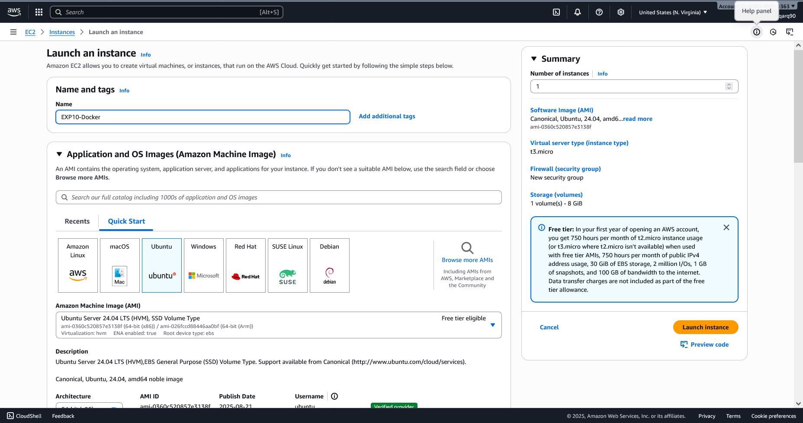

Setting up the EC2 Instance

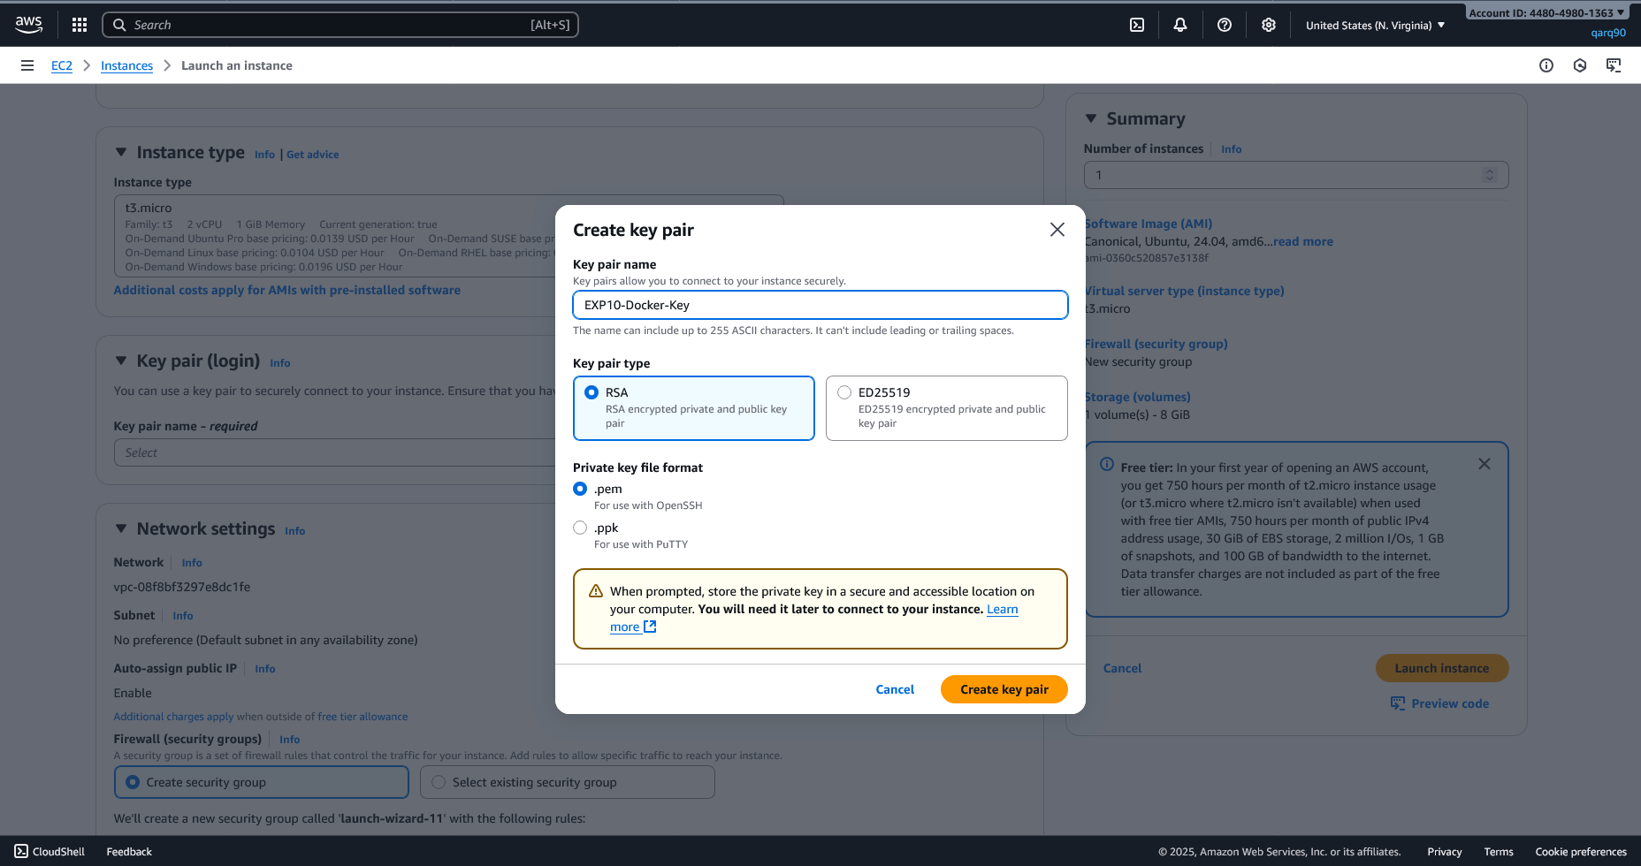

Creating Key Pair

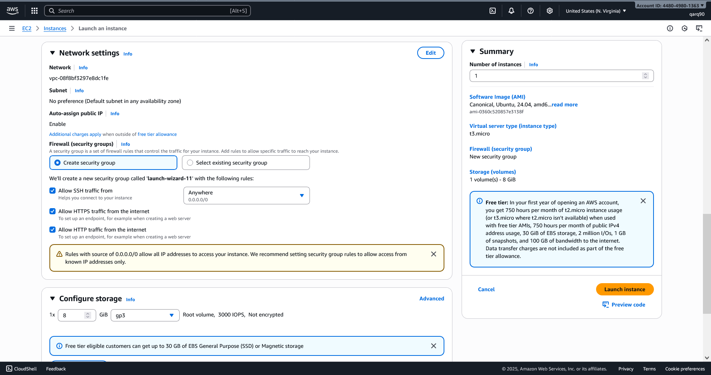

Configuring Network Settings of the Instance

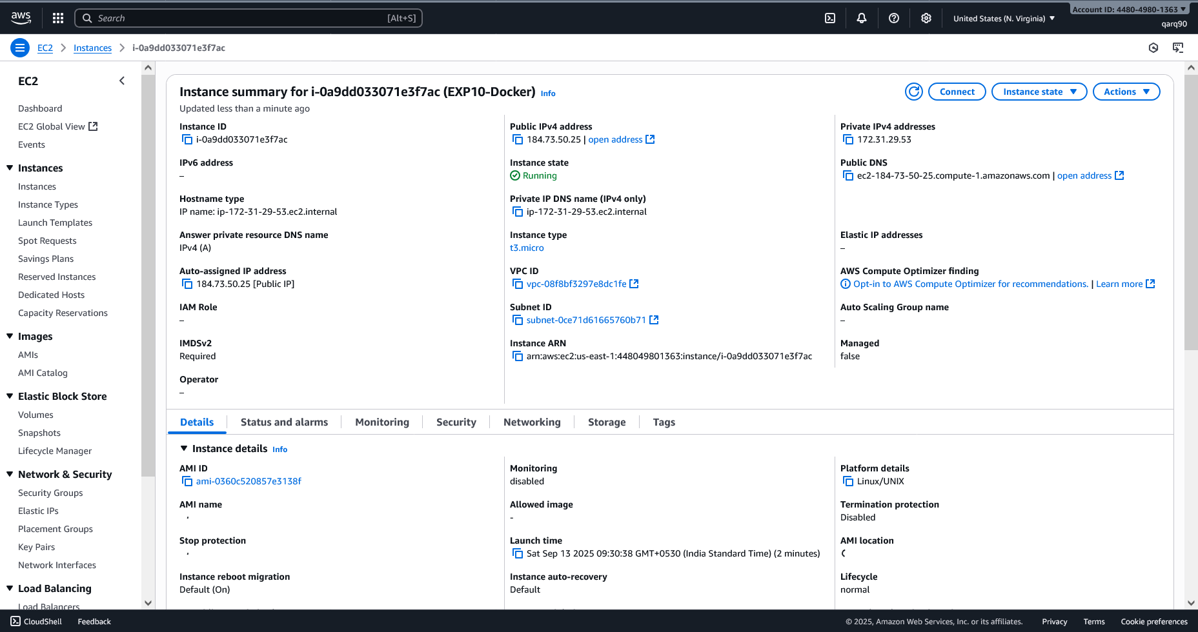

Instance Details

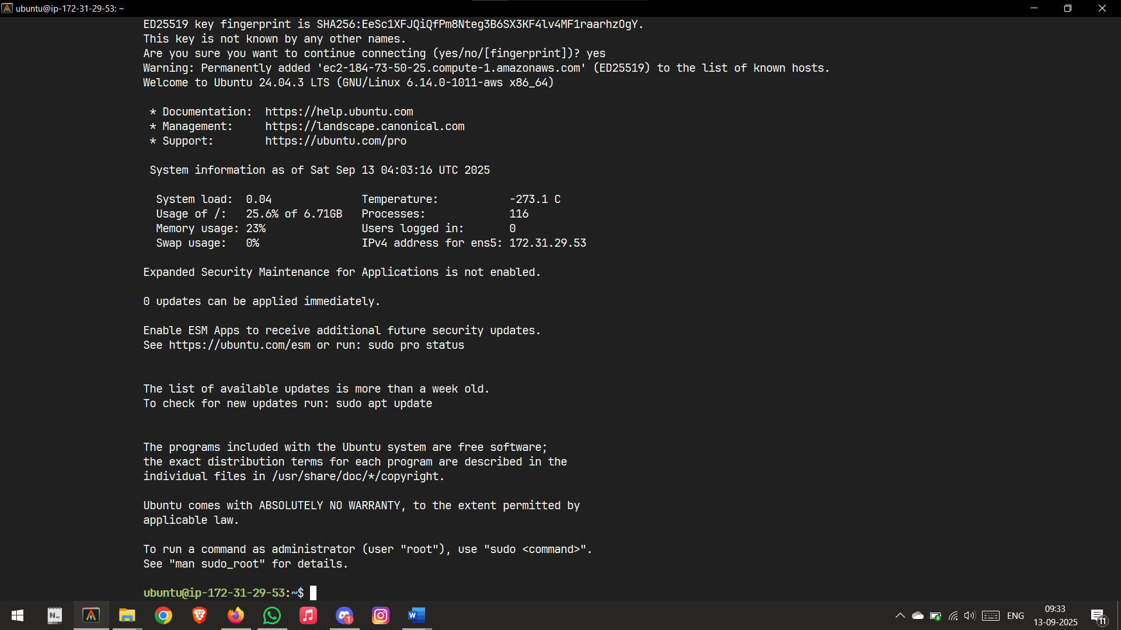

Connected to Instance

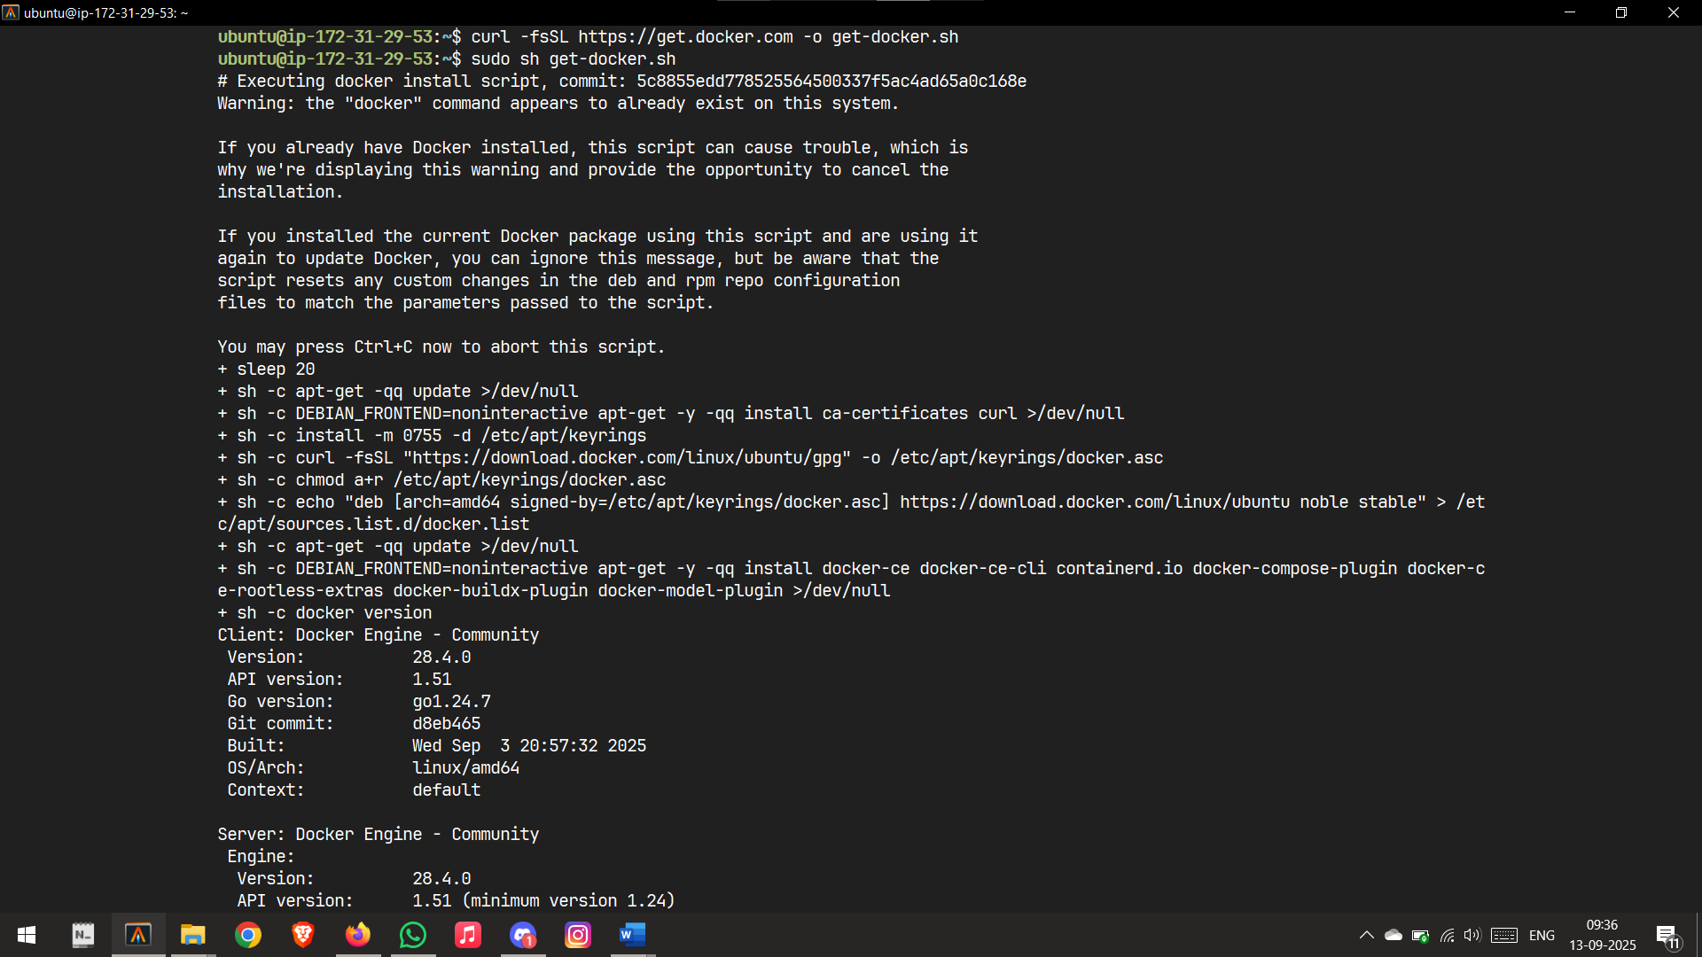

Installing Docker

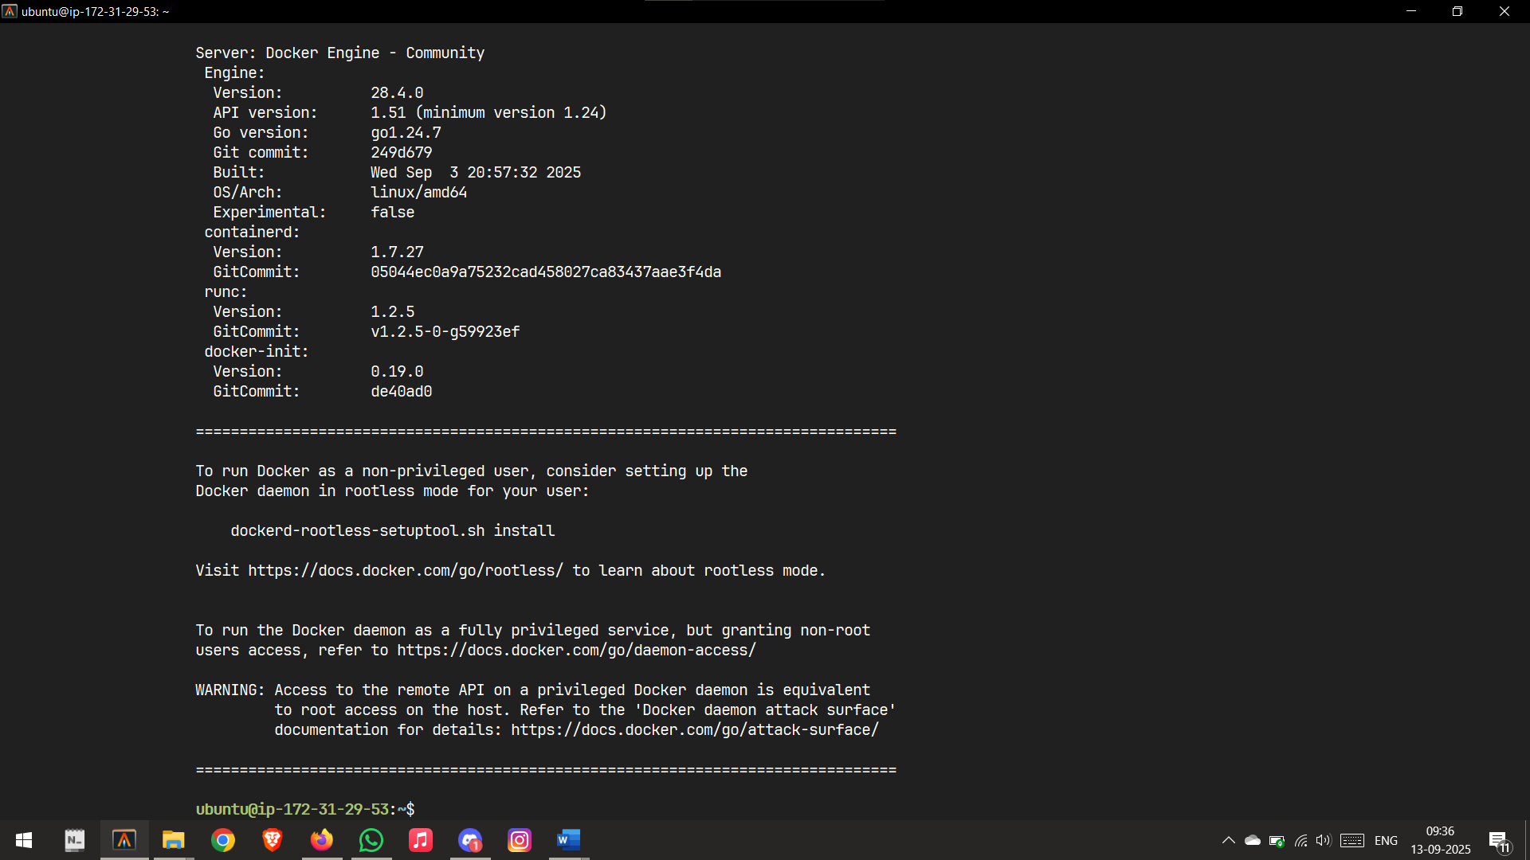

Configuring Docker

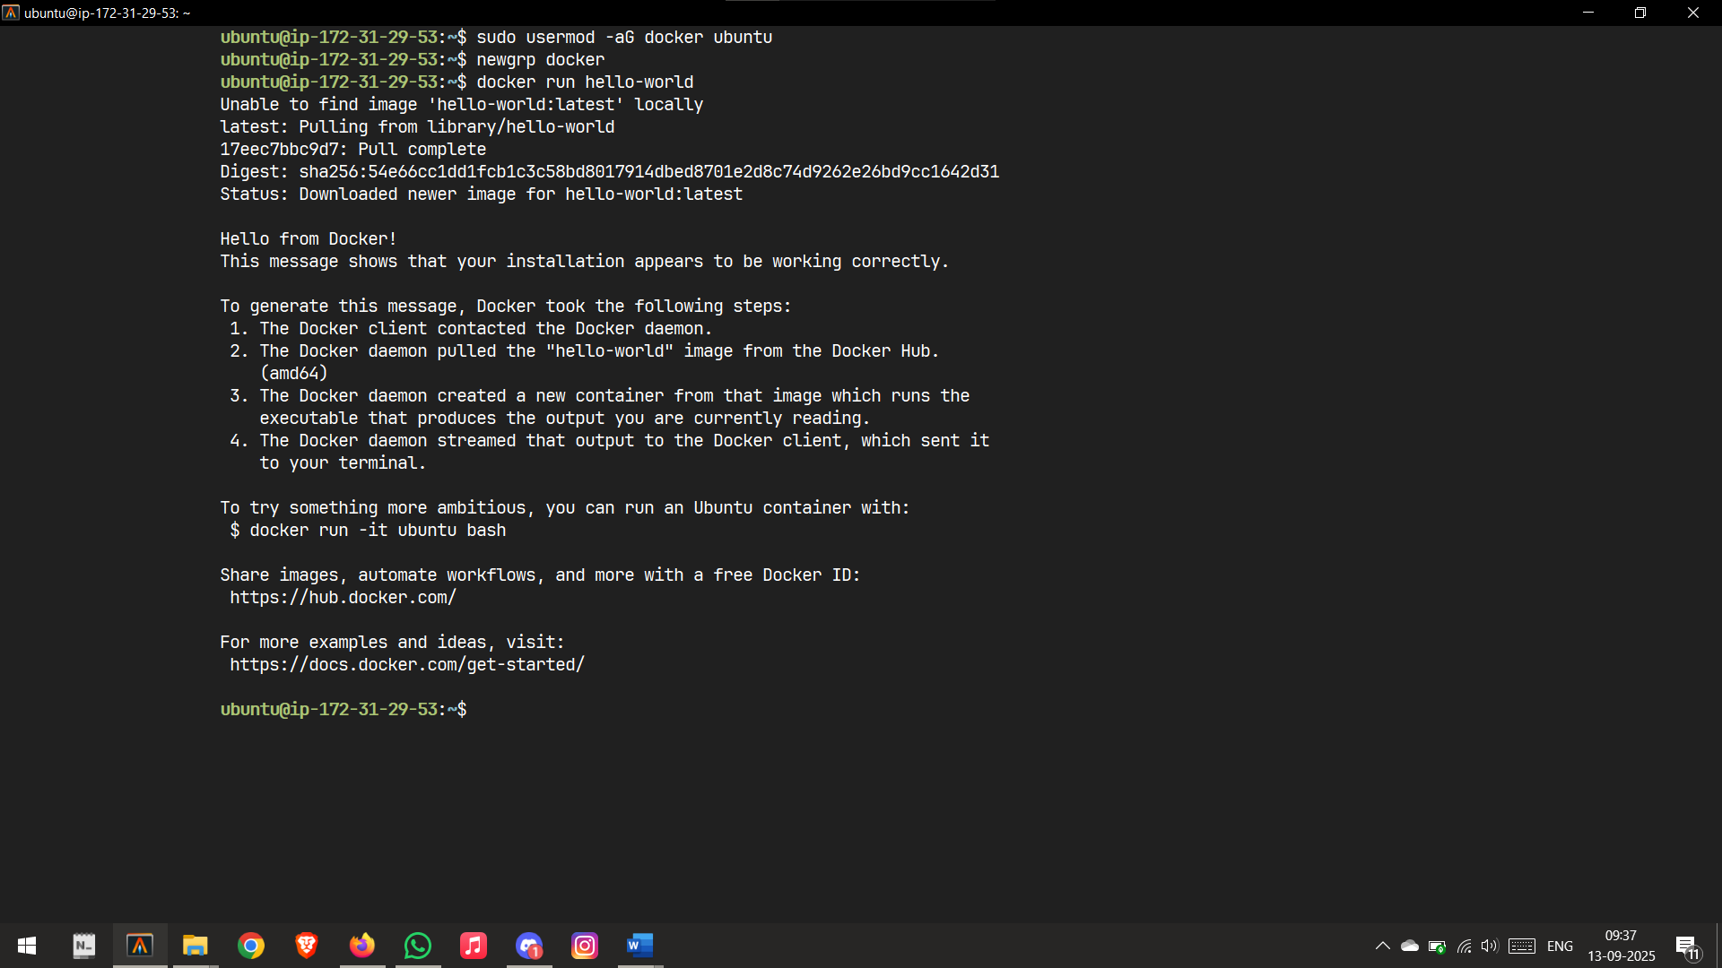

Configuration Complete

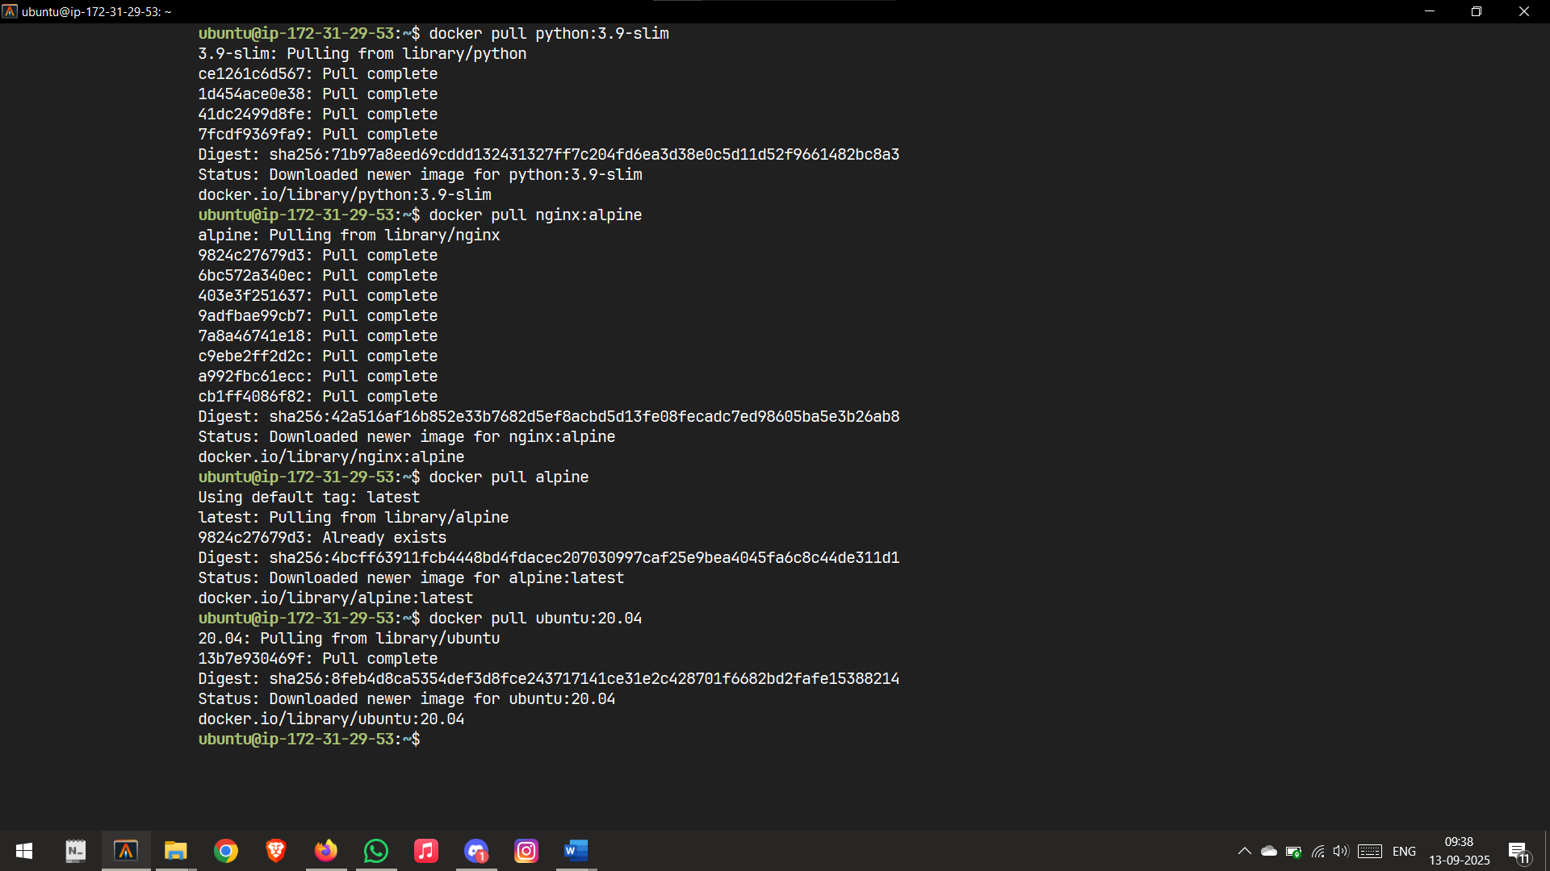

Pulling some images

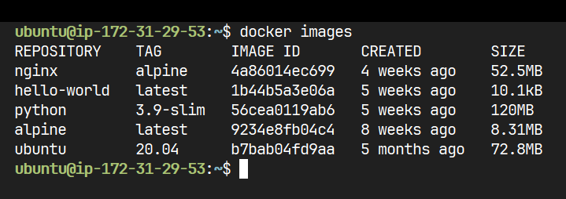

Images installed so far



Running a simple python code

Docker Commands:



Run a container in the background



List running containers

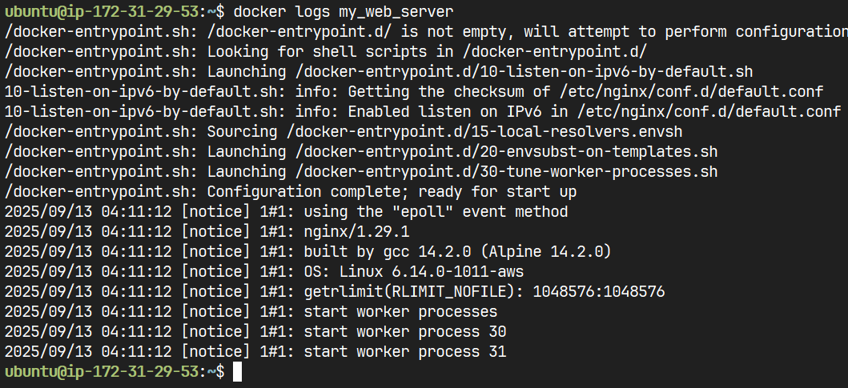

View container logs

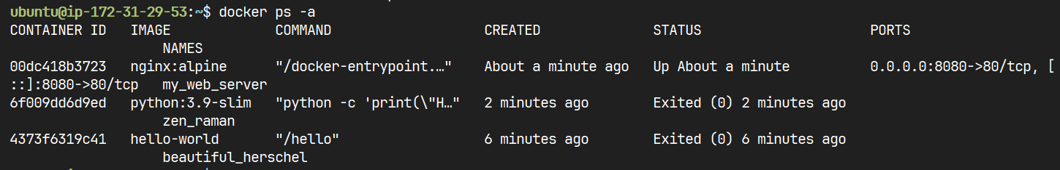

List all containers, including stopped ones



Create a new container



Start a container



Check Docker Version

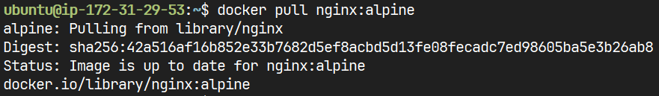

Download an image from a registry like Docker Hub without running it.

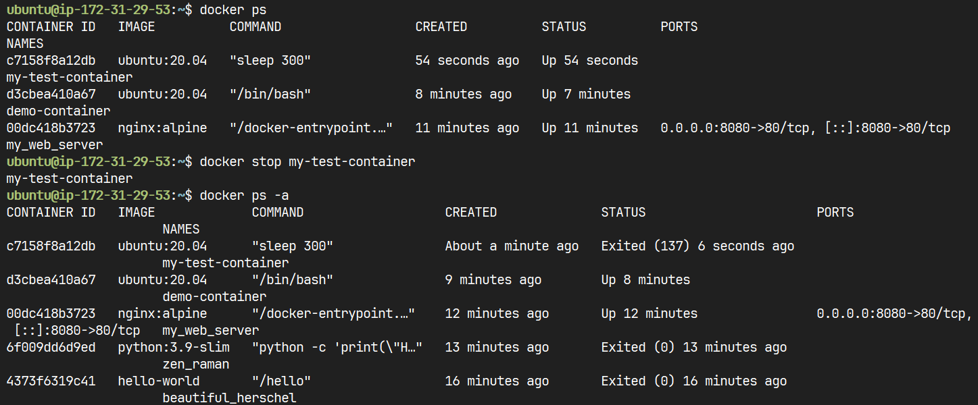

Stop a Container

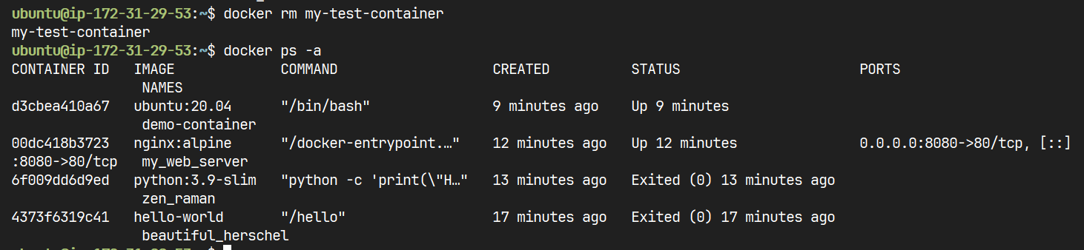

Remove a Container

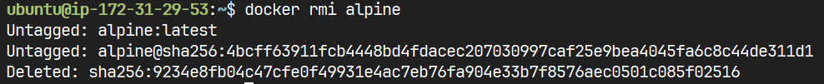

Remove an Image

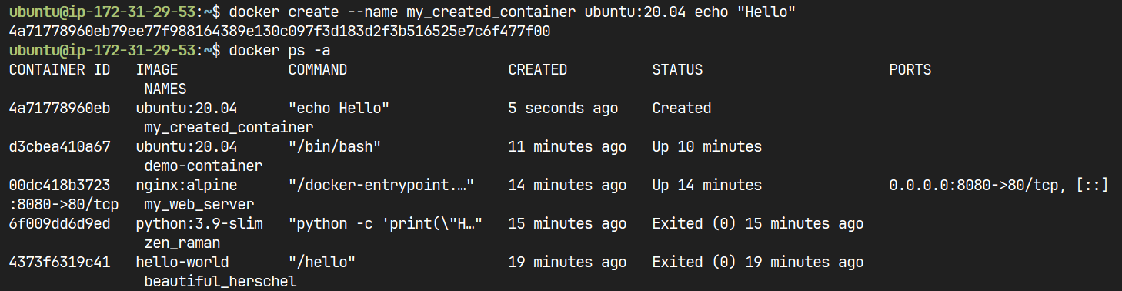

Creates a new container from an image but does not start it



Display the running processes of a container

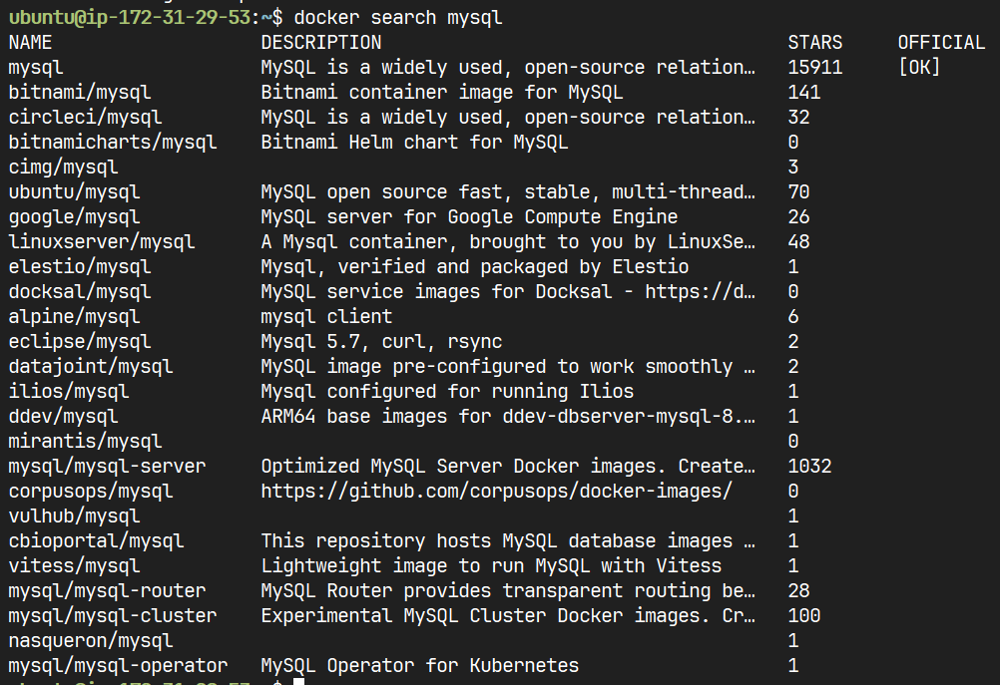

Search Docker Hub for images

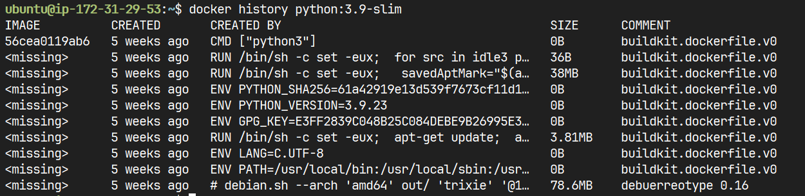

Show an image’s history